Date: 27-10-2025
Name: Chetti Rishika
Mtech – 1st Year
HTNO: 2503B05204

Lab 1: Environment Setup – GitHub Copilot and VS Code Integration

Task Description
- Install and configure GitHub Copilot in VS Code. Take screenshots of each step.
Expected Output
- Install and configure GitHub Copilot in VS Code. Take screenshots of each step.

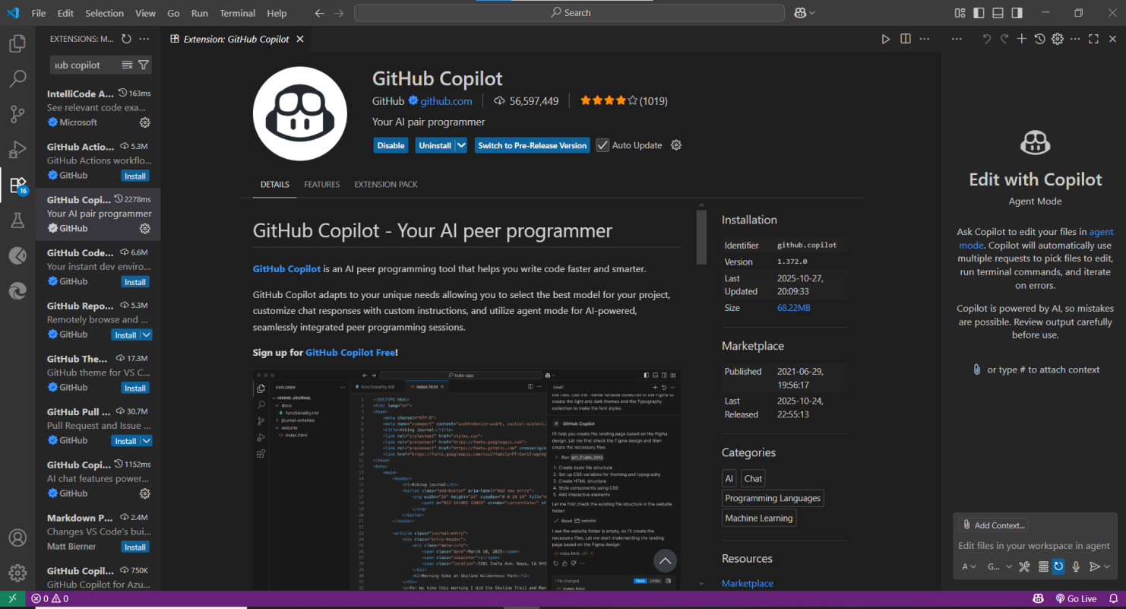

Task Description-1
- Use Copilot to generate a is_prime() Python function.
Expected Output-1
- Function to check primality with correct logic.

Prompt -1
Generate a Python function to find whether a number is prime or not.
Prompt-2
Update the function to take user input for a number.
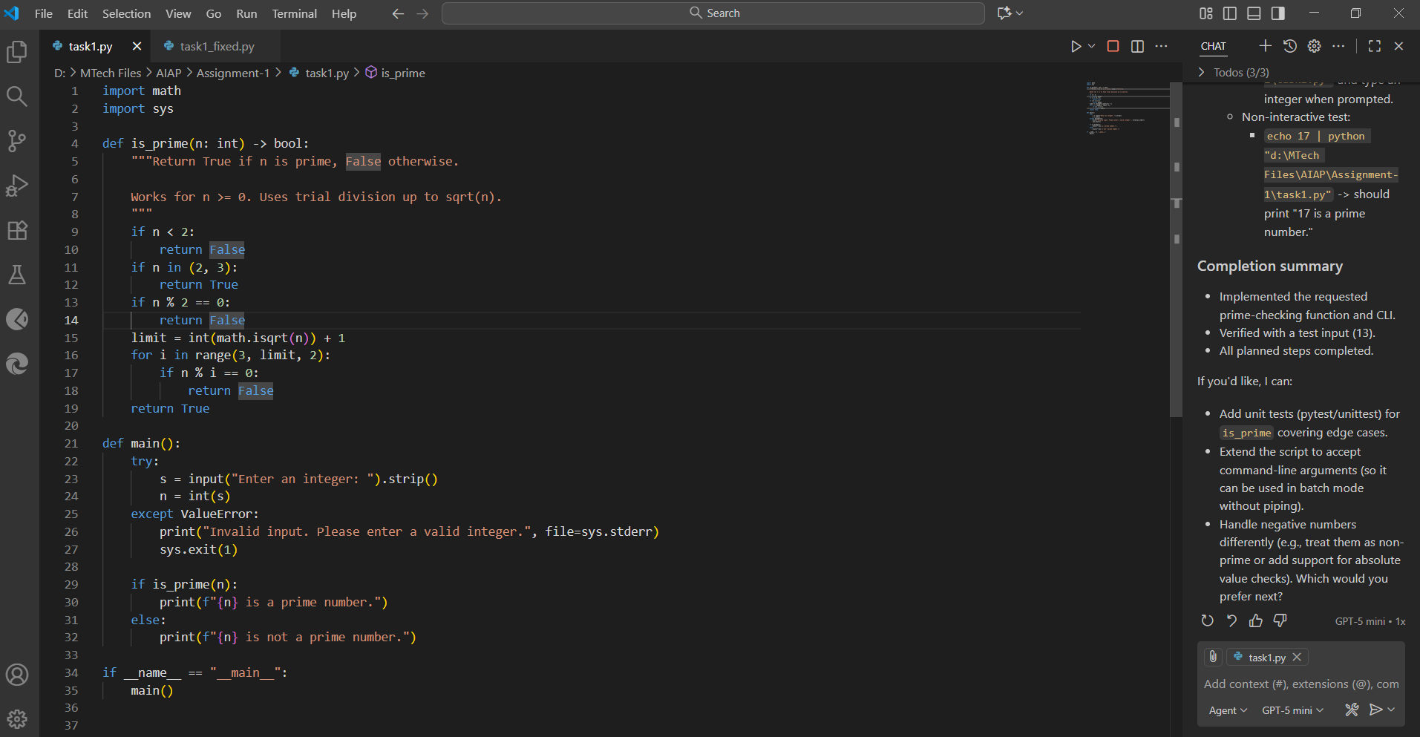

Output:

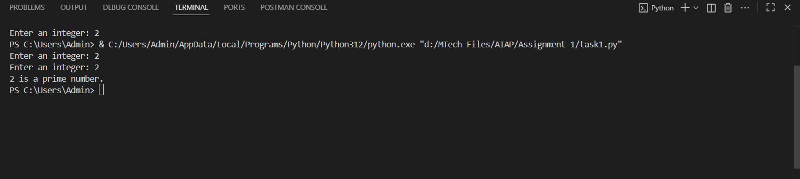

Task Description-2
- Write a comment like # Function to reverse a string and use Copilot to generate the function.
Expected Output-2
- Auto-completed reverse function

Prompt-1

Function to reverse a string where the expected output is to autocomplete the reverse function.
Prompt-2
Update the code to take user input manually

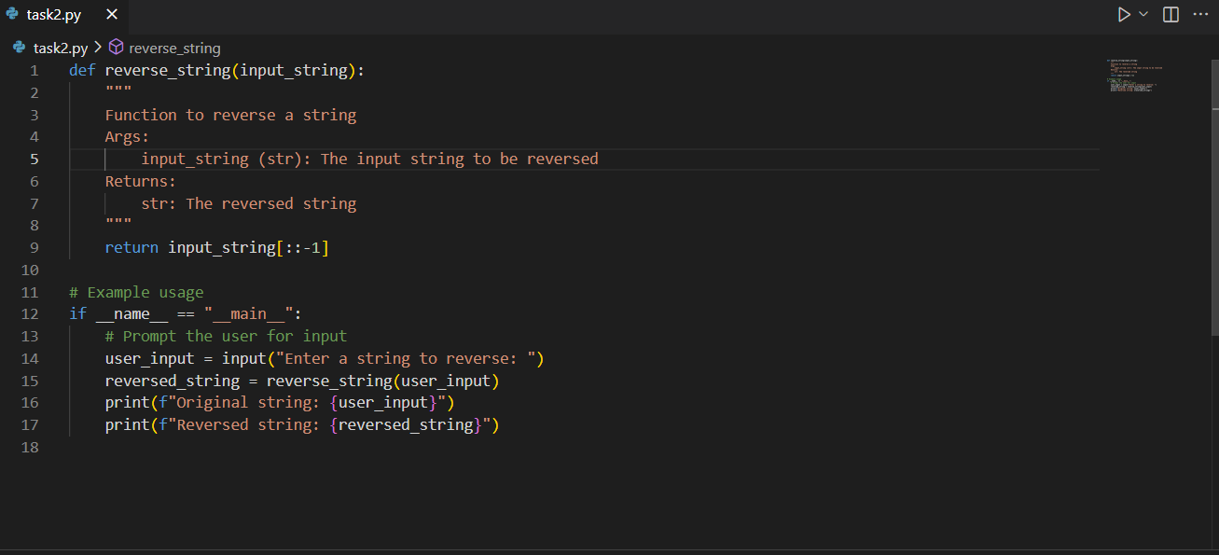

Output:

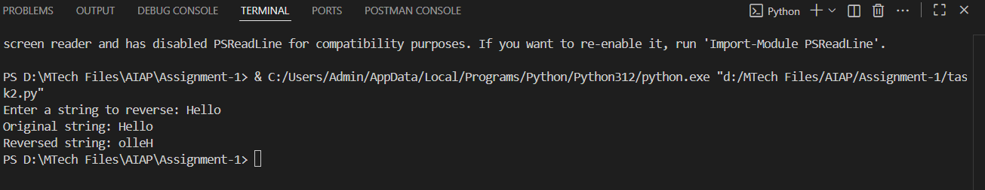

Task Description-3
- Generate both recursive and iterative versions of a factorial function using comments..
Expected Output-3
- Two working factorial implementations

Prompt-1
Generate both recursive and iterative versions of a factorial function in python.
Prompt-2
Update the code to take user input manually.

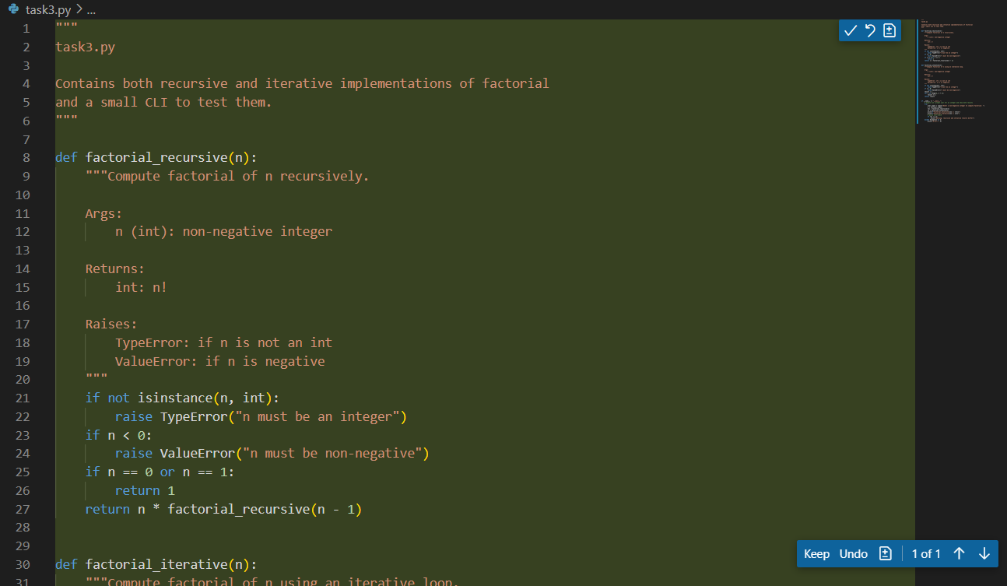

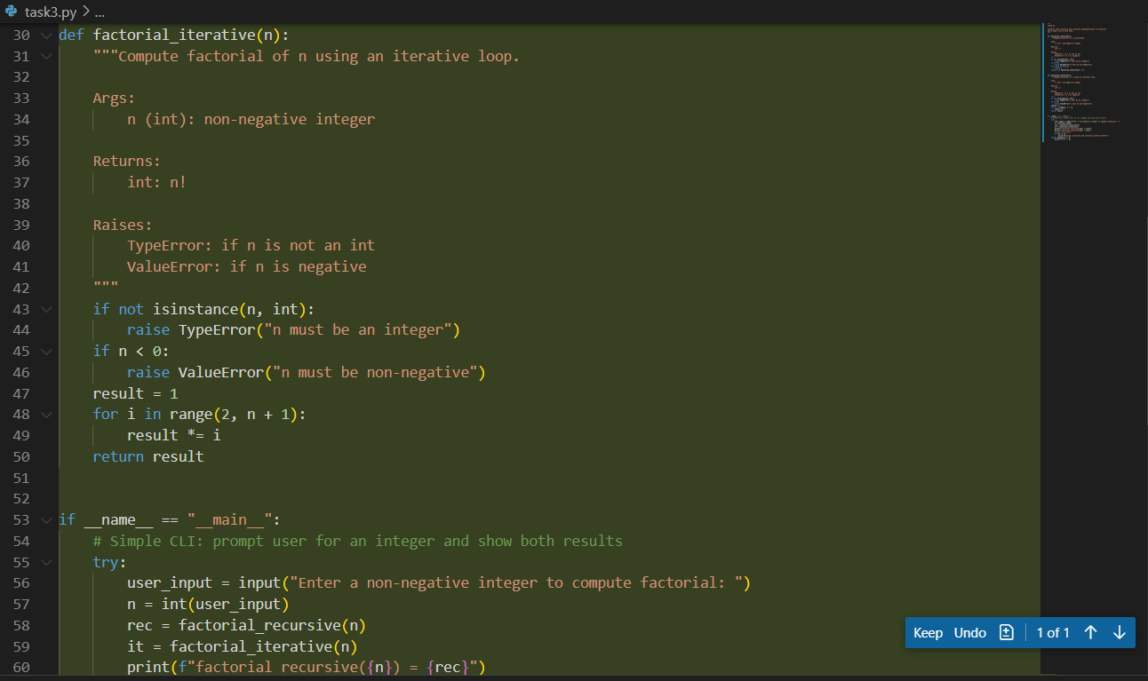

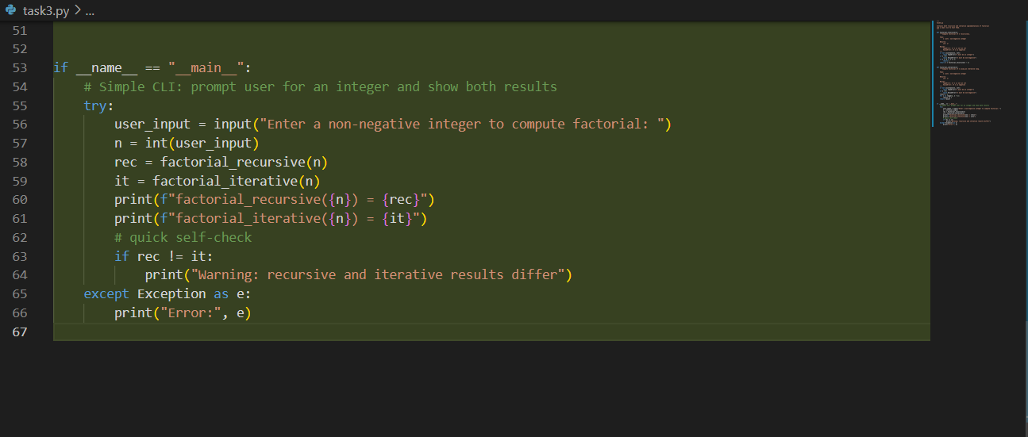

Output:

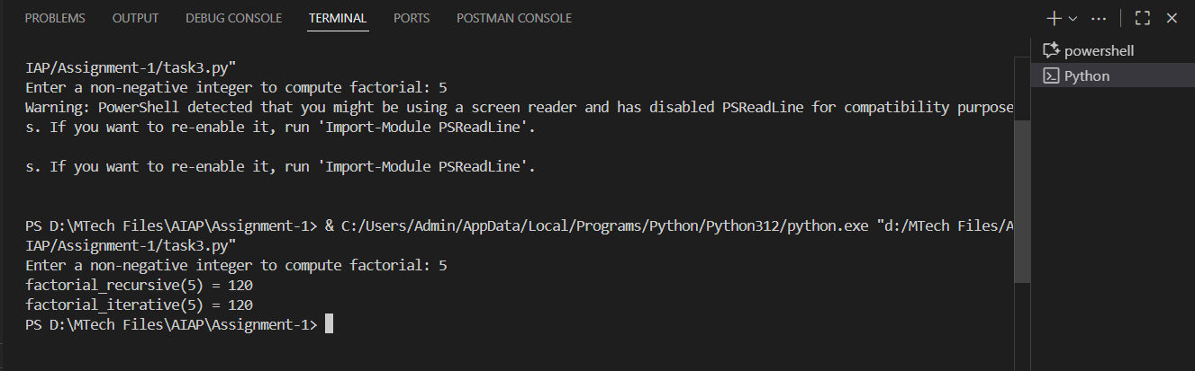

Task Description-4
- Use Copilot to find the largest number in a list. Assess code quality and efficiency.
Expected Output-4
- A valid function with your review

Prompt
Generate python code to find the largest number in a list by taking user input manually.

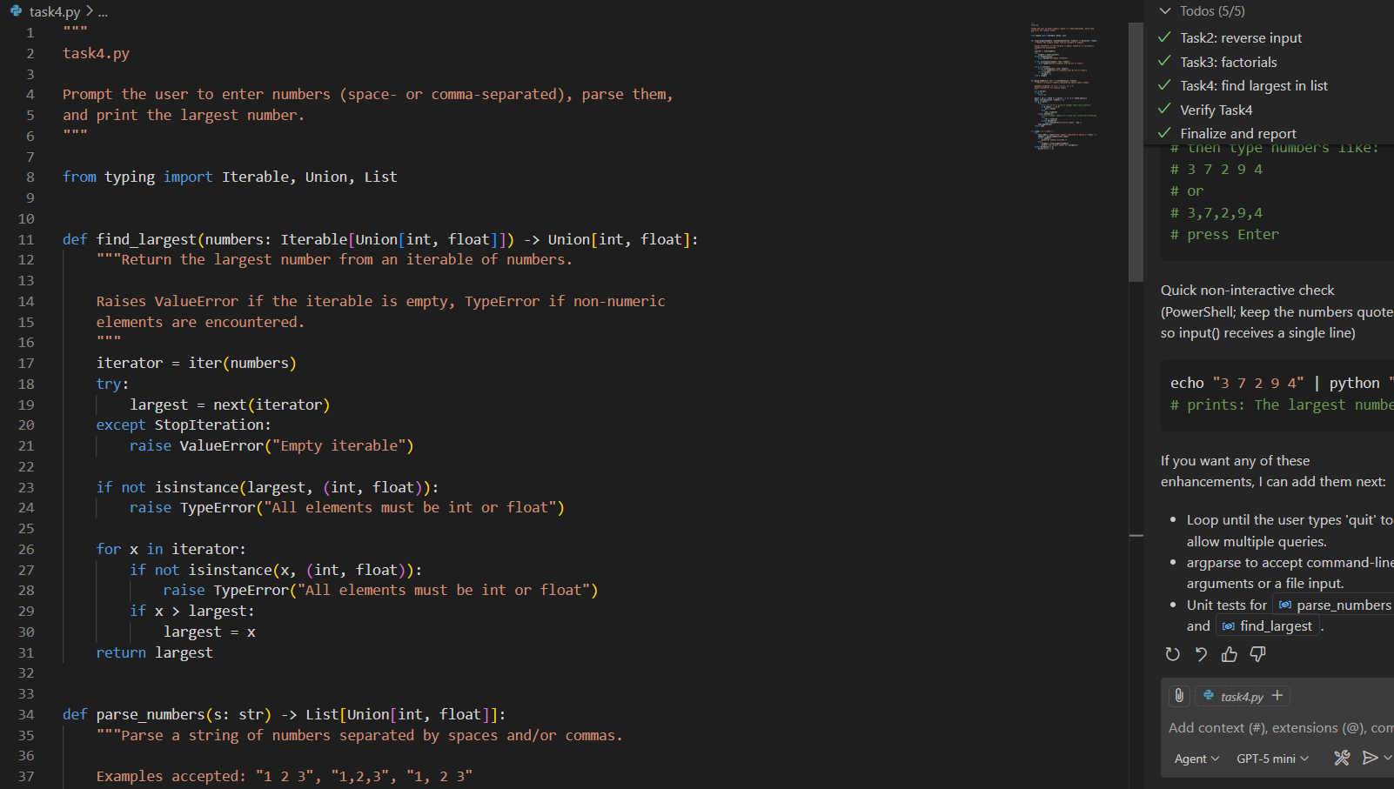

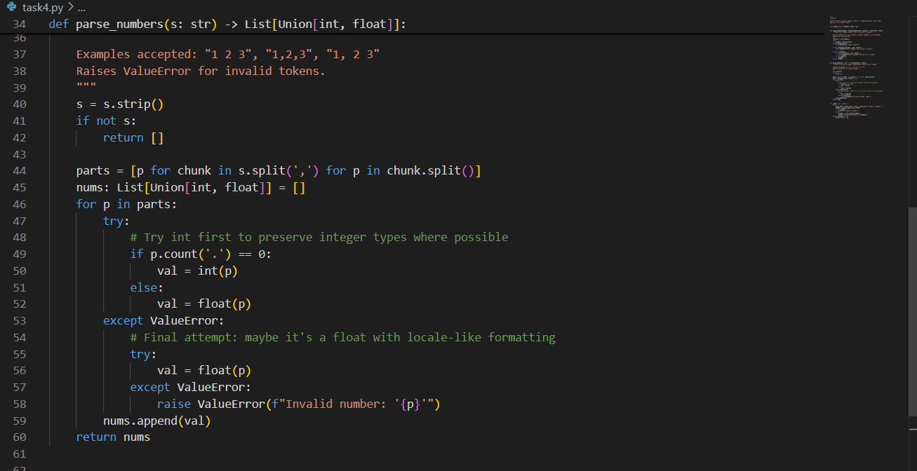

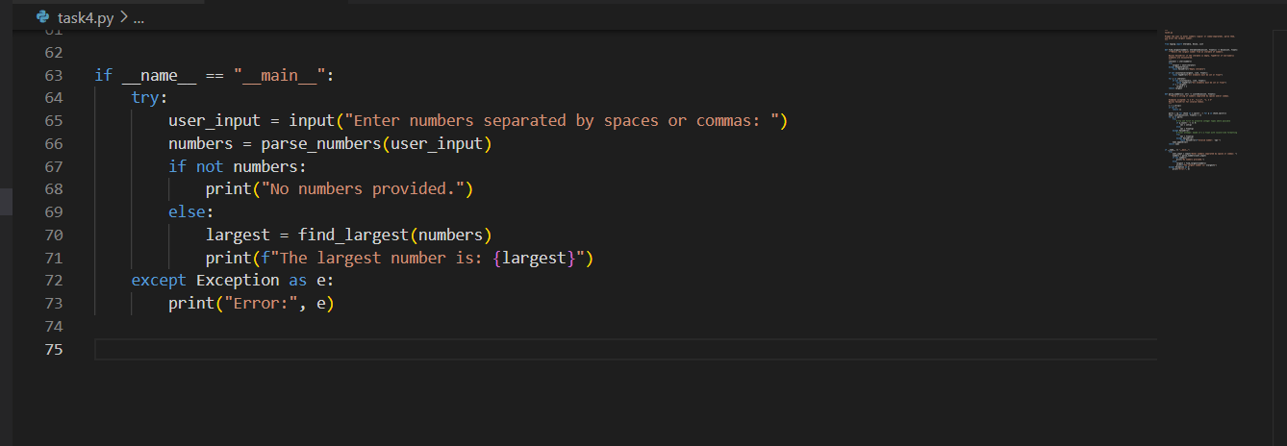

Output:

